Of interest to Lakewood Residents

Hazardous Waste Drop off day.
April 24, 2021 8:30- 11:30
Public Works Laydown Yard
1205 15th Avenue N
Bessemer, AL 35020
Cooking oil, paint, papers for shredding (5 box limit), yard chemicals, Rx drugs, tires, large appliances (washers, dryers), compact fluorescent bulbs, motor oil and vehicle fluids, propane tanks, electronics (cell phones, tv’s, computers).
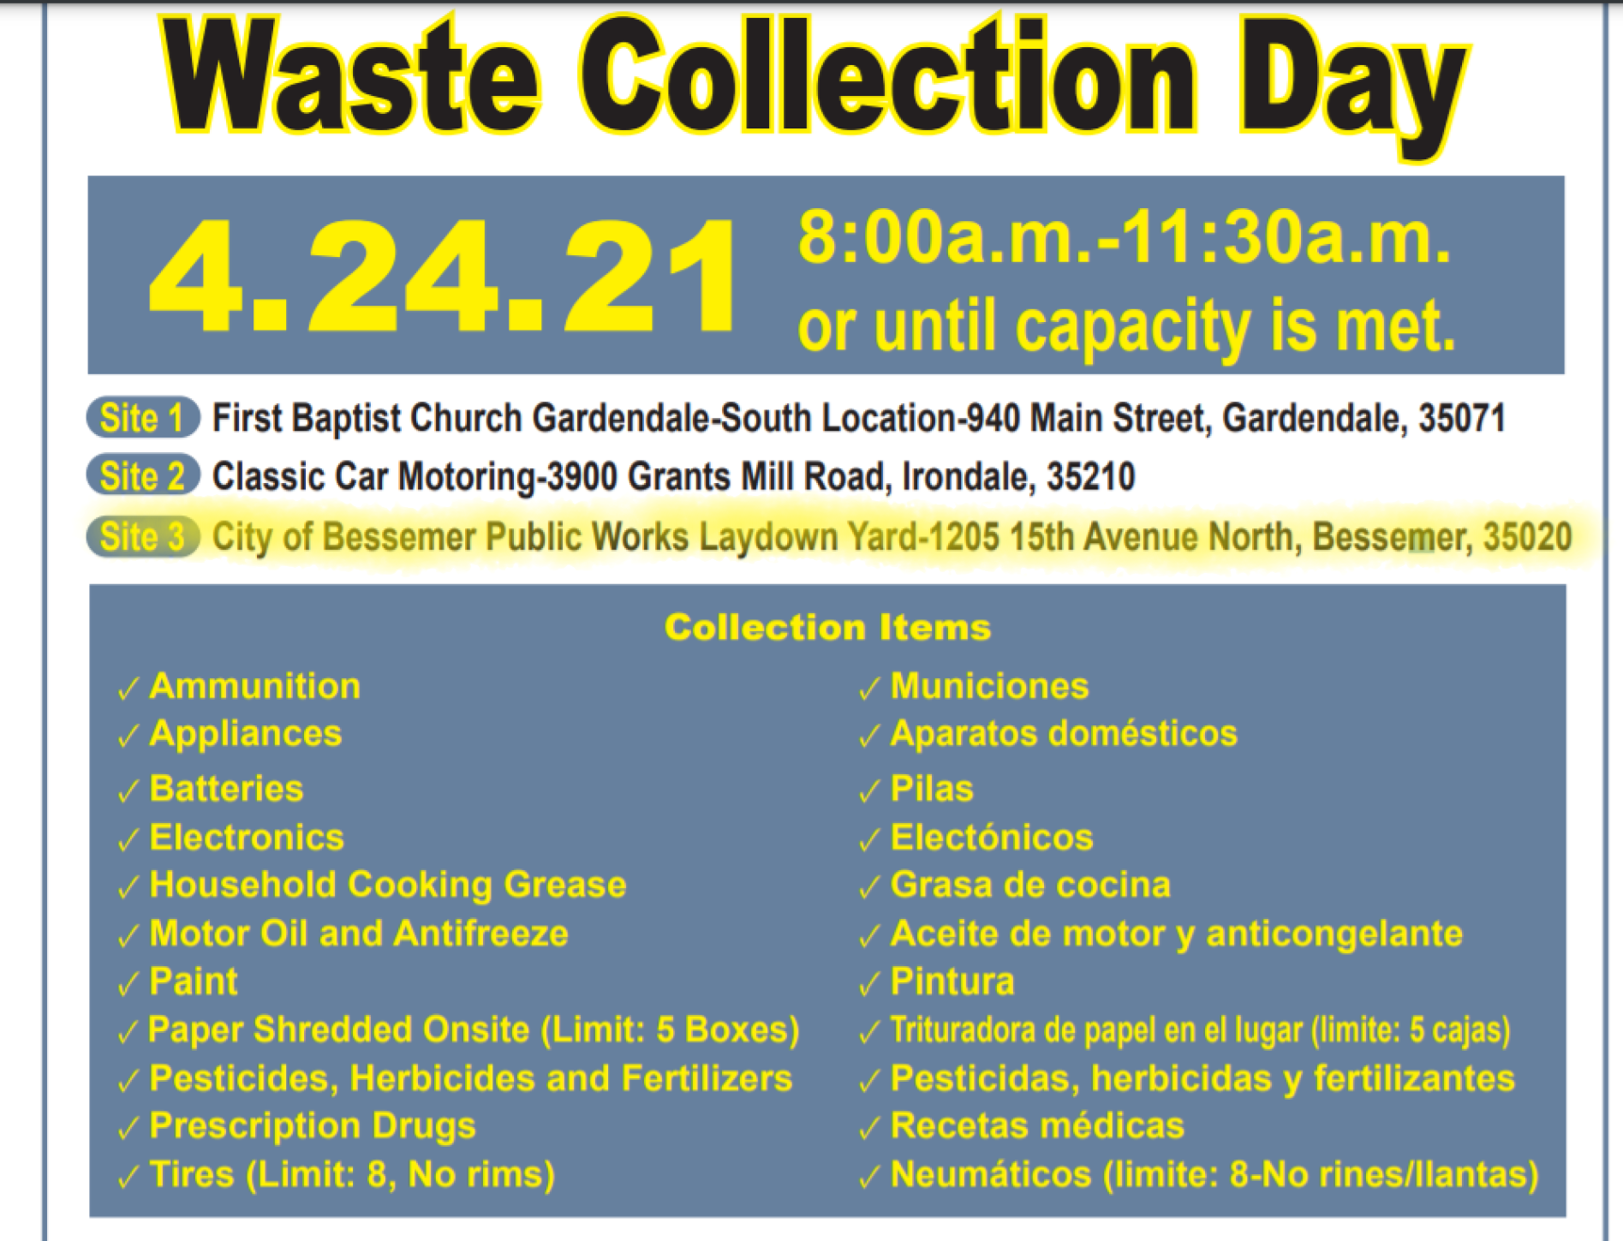

***If anyone is going and has room to take some stuff for us, I will be at the Farmers Market that morning and Bobby will be working. Let me know if you can help us out.***
This beautiful Luna Moth (Actius luna)
was recently seen. While not rare,
they are not often seen because they
usually fly at night. Their caterpillars
are large and green as well and are
found on a variety of trees in
Lakewood Estates, including Hickory,
Sweetgum, Walnut and various oaks.
The adult moths, as seen here, have no
digestive system, and do not eat.
Lakewood Estates
Newsletter Spring 2021
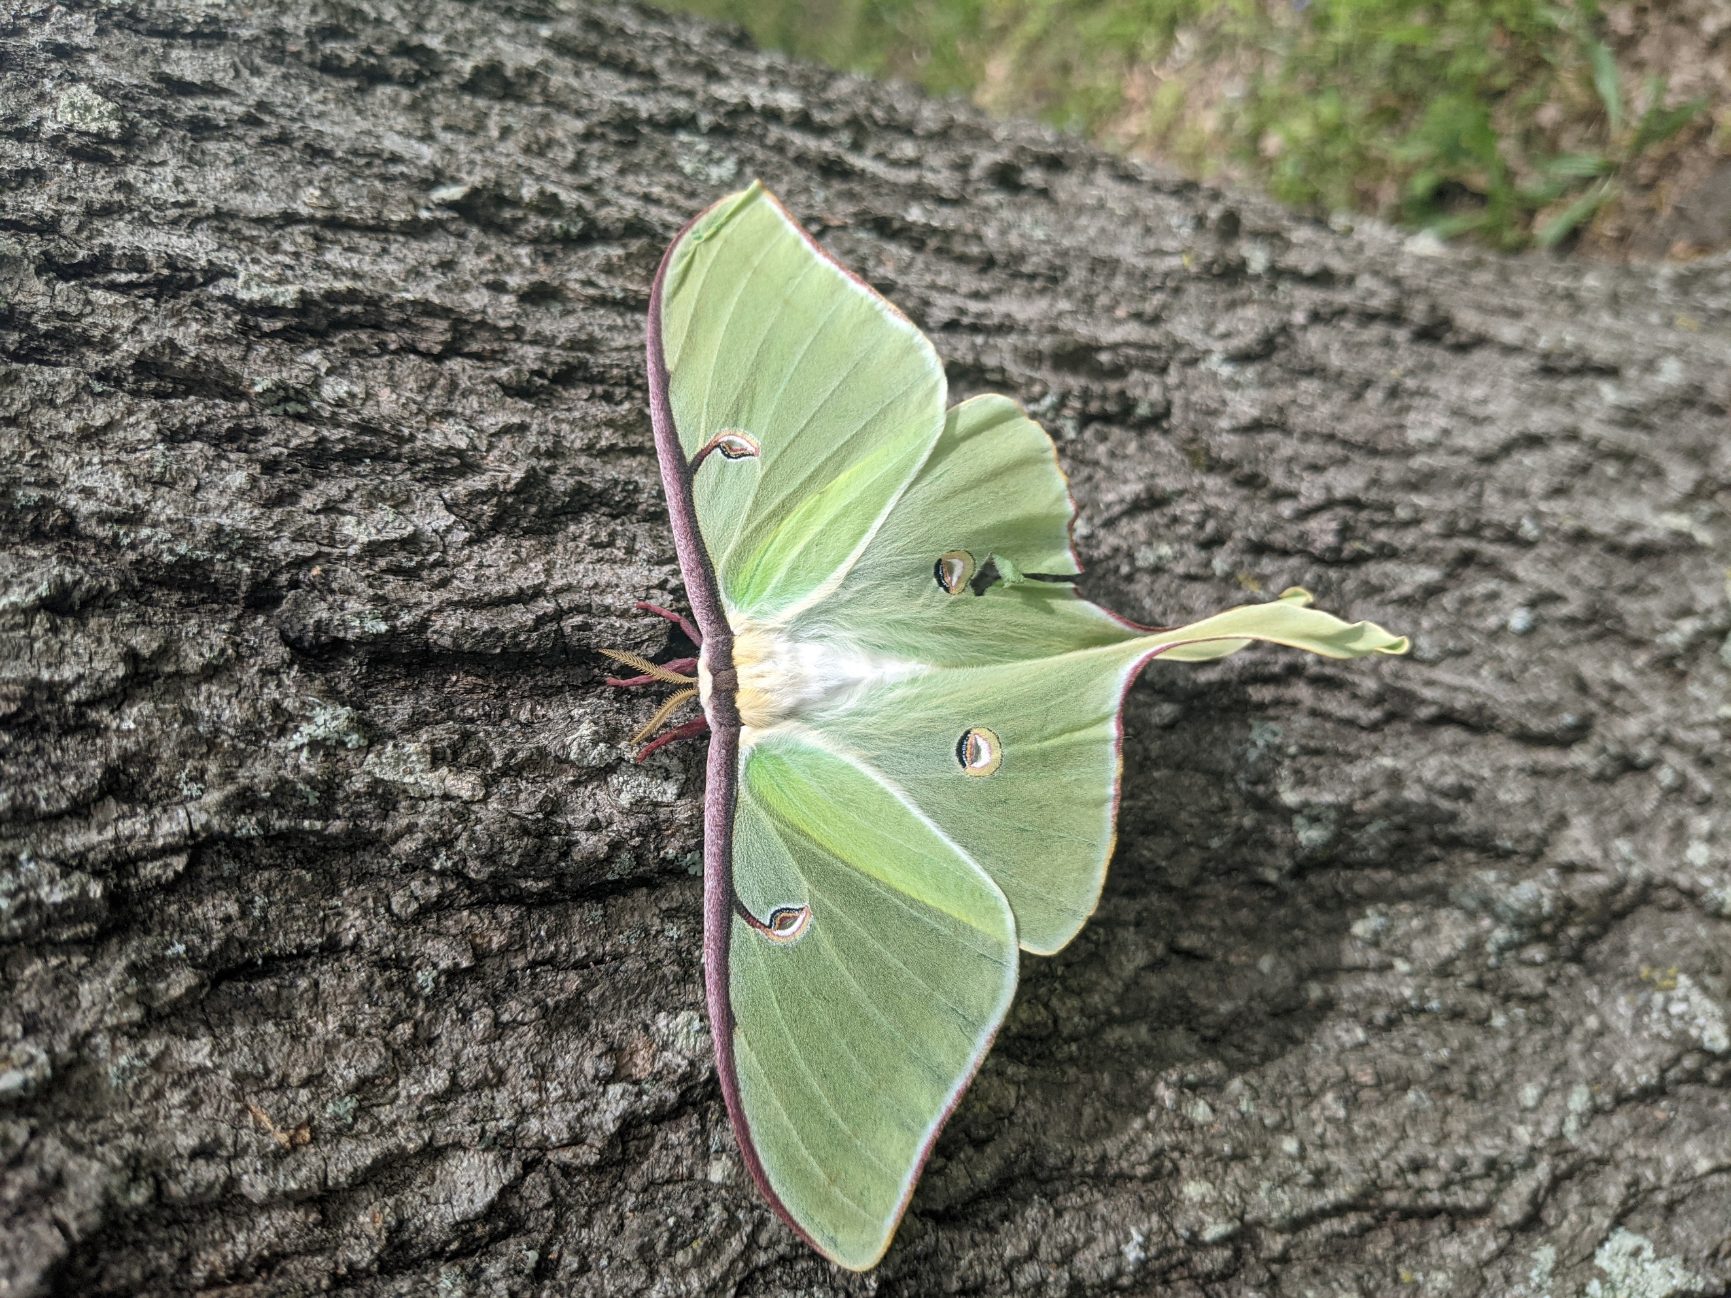
The females will emit strong sex
pheromones to attract males,
who can detect the pheromones from
several miles and fly to the female to
mate after midnight (researchers say).
Egg laying starts the night after mating,
and 200-400 eggs are laid on the undersides of leaves of the preferred tree.
Bumblebees and honeybees and native bees are all enjoying the flowers of spring. This bumblebee (and several others) enjoys the pollen and nectar of collard green flowers on plants that were allowed to bolt.
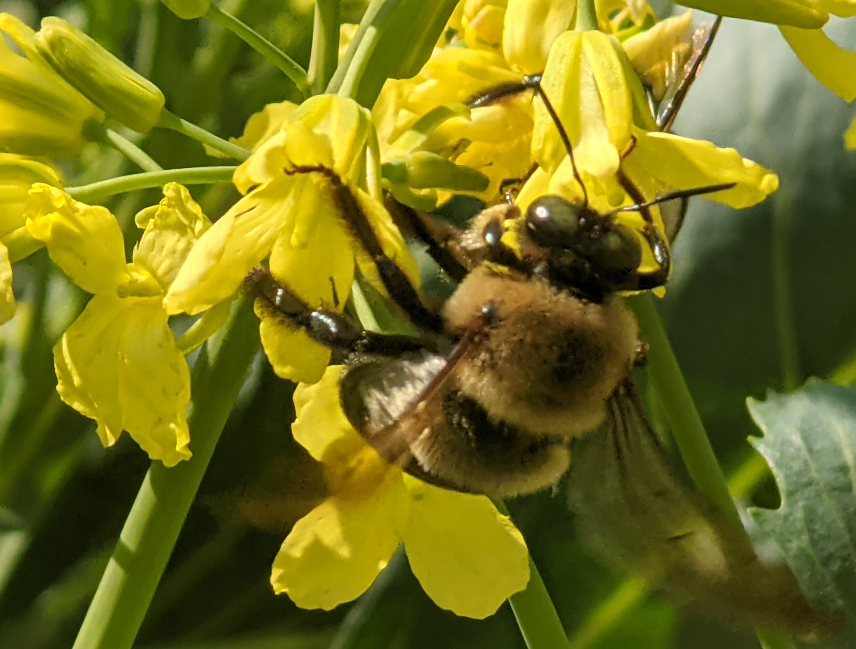
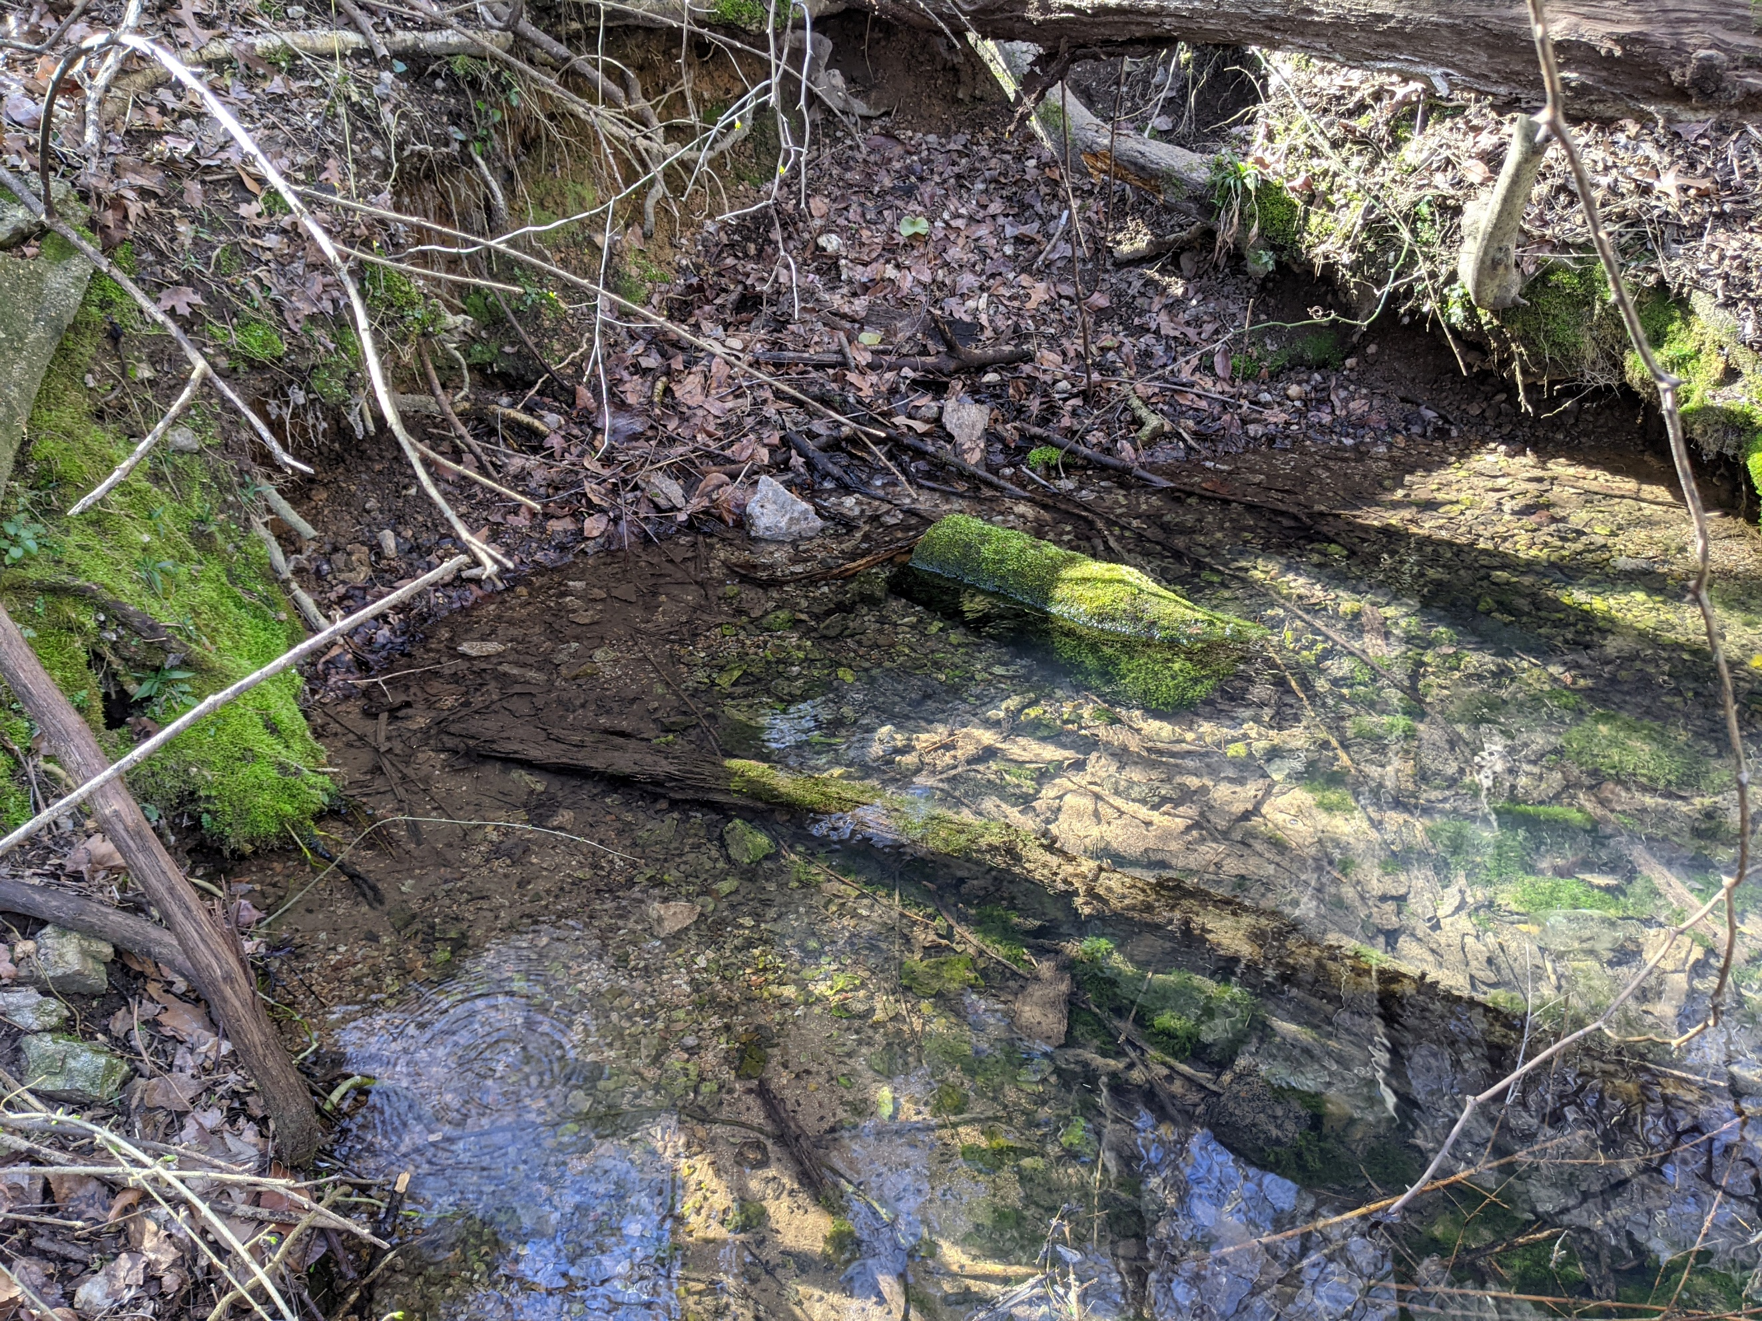
This picture shows Glen Spring at its origin. This is the water that feeds our lake, and the place where early residents picnicked and collected jugs of fresh spring water. Currently you would not want to picnic here.

